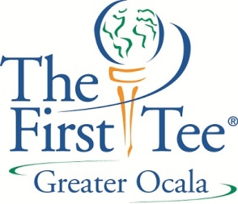
July 11, 2012
Dear Florida Junior Golf Council,
Thank you for your very generous grant. We are four weeks into our first summer and our programming is progressing wonderfully. We currently have 119 kids enrolled in our program and continue to grow almost daily as word of mouth continues to spread in our community. The kids in our program range in age from our Pre-PLAYer kids (age 5-6) to our most advanced kids who are of high school age, many of which are members of the local high school golf teams. Many of these older kids also volunteer in the program, working with the younger kids and gaining valuable leadership and mentoring experience.
Our kids are signed up for classes that meet once a week for an hour and a half. The kids also have the option to attend a two hour Optional Practice session and an Optional Play Day. The cost of the ten week program was one hundred dollars with the optional sessions being available on an ala carte basis at five dollars per session. As we enroll new kids into the program they pay a prorated amount based on the number of weeks remaining in the summer session. We currently have 10 of our 119 kids on full, needs based scholarships.
The program is being headed by Program Director, Chris Wilson. Chris is a former PGA member and has over 20 years of golf professional experience. His teaching staff is made up entirely of current or former PGA and LPGA members. All volunteers and coaches have been put through an extensive training program which has brought them up to speed on the teaching methods used by First Tee and the mission statement of Marion County Junior Golf, Inc. Our class size is restricted to no more than 20 players due both to space restrictions here at the Ocala Golf Club and an effort to maximize each students’ exposure to one on one instruction of both The First Tee’s Nine Core Values and the golf skills taught by our staff.
To date we have used the grant money primarily for two purposes. The first of which was to purchase SNAG golf equipment to teach our Pre-PLAYer golfers as well as our beginning golfers of all ages. The SNAG equipment will be vital to our future growth as it will be used in our outreach programming. We have already had early discussions with the local YMCA, Boys and Girls Clubs and both the Boy and Girl Scouts. All of these groups are essential to our growth. In addition to the purchase of the SNAG equipment, we have used some of the money to pay for daily usage fees at the facility as well as covering monthly rent for our office space at the Ocala Golf Club.
Your grant dollars have been instrumental in helping our program get off to the fantastic start we have. We look forward to continuing our relationship in the future and also to helping spread awareness locally of the tremendous value the Florida Junior Golf Council and the license plate program.
Respectfully Submitted,

Chris Wilson, Program Director, The First Tee of Greater Ocala

